The POLC is preparing an application to the International Dark Sky Assn. to request that the area known as the Hopewell Big Woods and a portion of the area contained within what is known as the Schuylkill Highlands be designated as the “Hopewell Big Woods International Dark Sky Reserve.” (See map below.) Included within the proposed area in southeastern PA in parts in Berks, Chester, Lancaster and Montgomery Counties, are situated the following significant venues: French Creek State Park, St. Peter’s Village, Hopewell Furnace National Historic Site, Joanna Furnace, Crow’s Nest Preserve, Warwick County Park and PA State Game Lands 43.
The aim of the Reserve designation will be to provide recognition of the work that has already been done in the region to control light pollution but more importantly to provide a rallying point around which to further educate and inform citizens, municipalities and businesses of the negatives associated with light pollution and can be done to keep its ill effects from increasing within and around the Reserve.
Excessive light at night disrupts animals’ natural cycles and reproductive and feeding habits. Unneeded light at night denies our ability to enjoy the wonders of the star-filled night sky.
The following map depicts the 3-mile radius Core and Zones 1 – 3, with Zone 1 being the most critical for excluding light at night within the Core.
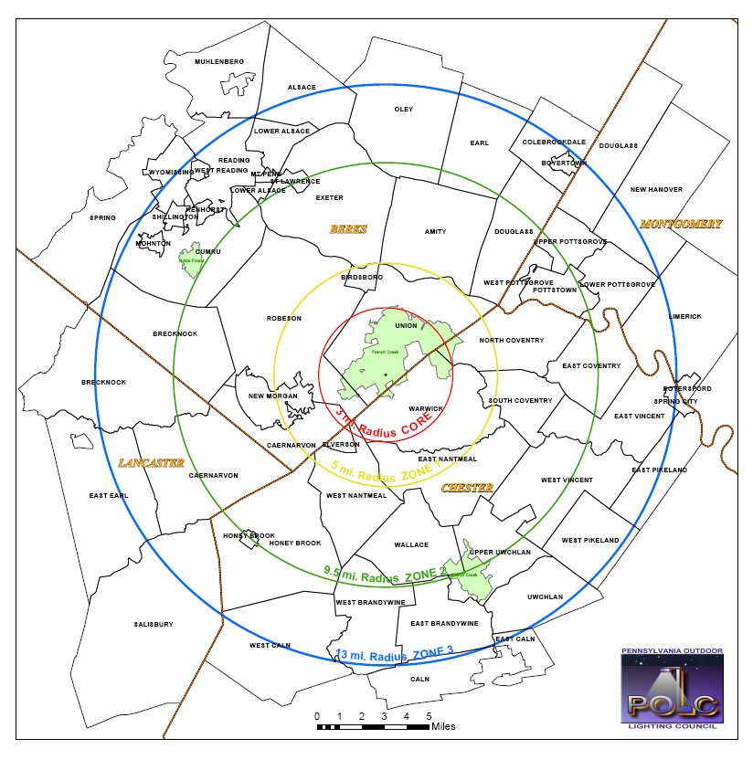
06/12/11

